Meeting Notes for Giao 9-3

9/3/2015

Takaji Messer

BROWSit C# Project

**Navbar** - Home, About, Info, Contact, Data, Reports

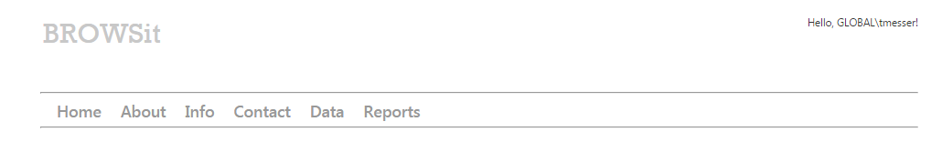

**C# MVC Code Areas**

* Data
* DB
* Reporting

Features:

* View BROWS DB data and interact through easy user controls
* View and create “reports” with more powerful direct SQL strings

To do:

* Provide login/logout interface and user authentication
* Look into connecting login to Tek LDAP (?)
* Add users and groups tables for permissions to view reports, edit reports, delete reports, categorize new reports by group, etc.
* Permissions for adding, editing, or deleting BROWS database entries (requirements etc.)

Discuss:

* Migrating Jira DB to MySql – cost/benefit?
* LDAP Authentication for BROWSit?
* Redundancy of BROWS fields such as prefix, etc.
* What is the ideal workflow?
* Should users be able to add requirements, edit requirements, delete requirements, etc. from this tool?

**Data** – Where the user can easily access/view data in the database. All data is managed by user controls with the Entity Framework. No raw SQL is used.

Features:

* Select table and display contents
* Sort up/down on column
* Show/hide columns
* Display equivalent raw SQL string (query is NOT raw SQL, though)
* Export as New Report

To do:

* Replace “Results Per Page” (not working) with “Grab First ___ Rows” (reword)
* Export as excel (.xml) file

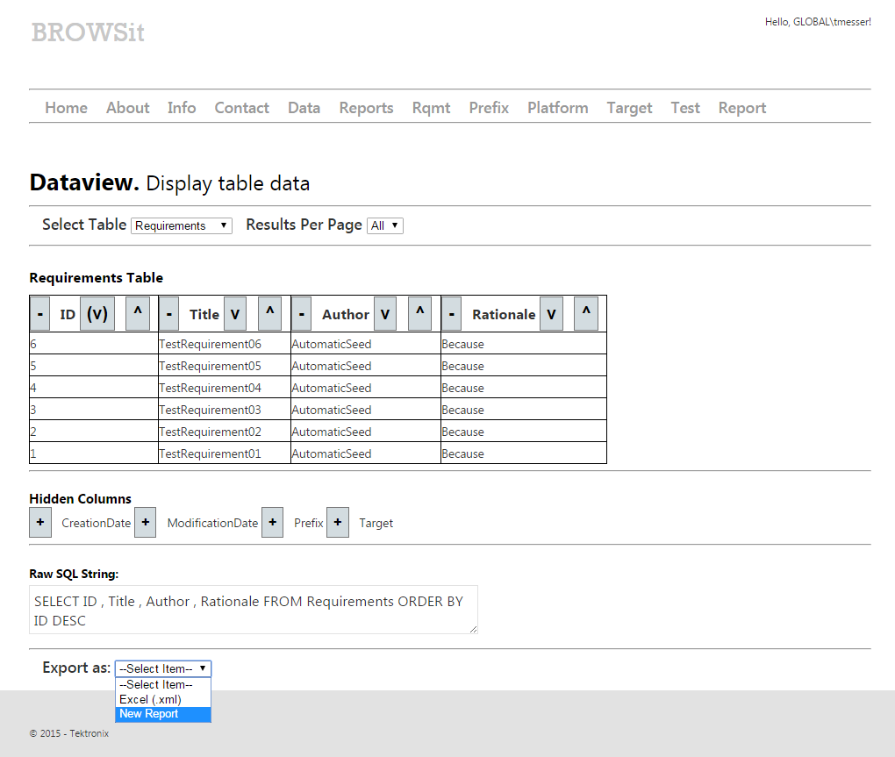

**Reporting** – Where the user can create and view reports. No Entity Framework is used; instead, raw SQL strings are processed. If the user is uncomfortable, they can use *Data* to create raw SQL string first through user controls, before exporting as a new report.

Features:

* Display contents of reports list
* Sort up/down on column
* Show/hide columns
* Display equivalent raw SQL string (query is NOT raw SQL, though)
* Export as New Report

To do:

* Replace “Results Per Page” (not working) with “Grab First ___ Rows” (reword)
* Export as excel (.xml) file

